1. **Agenda**:
   1. Why it is called bullish Engulfing Pattern?
   2. How is it created?
   3. What is going on behind the scenes?
2. **For example**, if the market is coming down represented by black candle and suddenly we have long white candle (white candle body engulfing the complete black body) as shown below. This is referred to as **Shifting Psychology**.
3. 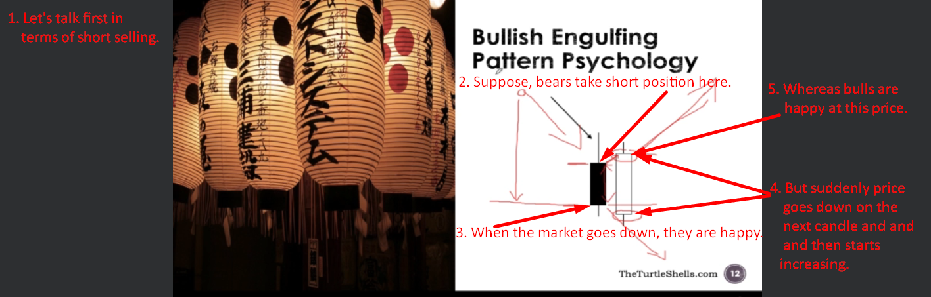
4. 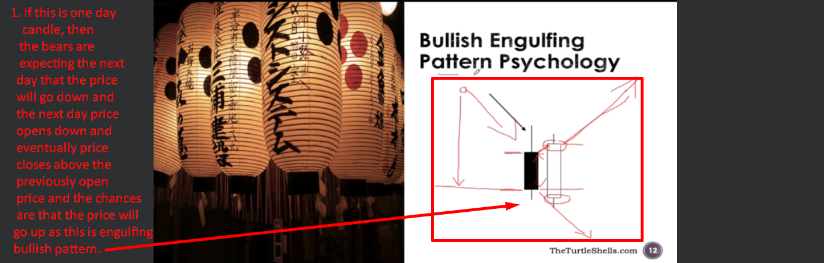
5. A graph with red lines and text

   Description automatically generated
6. 